Mô hình:

Model: "LeNet5"

_________________________________________________________________

Layer (type) Output Shape Param #

=================================================================

conv2d_2 (Conv2D) (None, 24, 24, 6) 156

max_pooling2d_2 (MaxPoolin (None, 12, 12, 6) 0

g2D)

conv2d_3 (Conv2D) (None, 8, 8, 16) 2416

max_pooling2d_3 (MaxPoolin (None, 4, 4, 16) 0

g2D)

flatten_1 (Flatten) (None, 256) 0

dense_3 (Dense) (None, 120) 30840

dropout_2 (Dropout) (None, 120) 0

dense_4 (Dense) (None, 84) 10164

dropout_3 (Dropout) (None, 84) 0

dense_5 (Dense) (None, 10) 850

=================================================================

Total params: 44426 (173.54 KB)

Trainable params: 44426 (173.54 KB)

Non-trainable params: 0 (0.00 Byte)

Hyperparameters:

* SGD
* Lr= 0.001
* Loss = sparse_categorical_crossentropy
* Batch size = 64

Config FL:

* 40 client
* Chọn 12 client mỗi round

Centrailized Results

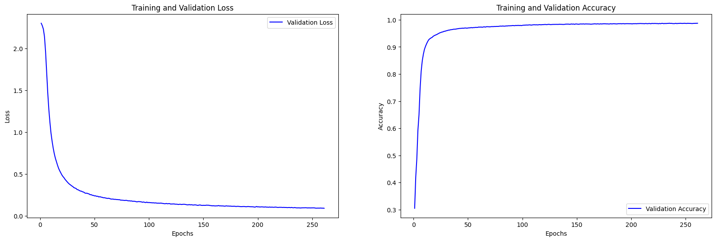

Accuracy: 0.9872

Alpha = 1

FedAvg với epoch = 1

FedAvg khác epoch

FedImp với epoch = 1

FedImp khác epoch

Proposed Algorithm

Alpha = 50

Alpha = 100